Calibrating a Function Generator
Daksh Khandelwal
PHYS 263
April 13, 2026

Abstract
The frequency accuracy of a BK Precision 4011A function generator was evaluated at 1 kHz and 5 kHz using Fast Fourier Transform (FFT) analysis. Two independent measurement techniques were employed: the Tektronix TBS1000B oscilloscope’s built-in hardware FFT and an offline software FFT computed in Python from the oscilloscope’s raw time-domain samples. Measured peak frequencies were compared to the function generator’s dial settings using a t-test methodology, with the FFT bin width serving as the standard uncertainty. Gaussian probability density functions were constructed for each measurement to visualize the confidence intervals. All four measurements yielded t-values below 1.0, indicating that no statistically significant discrepancy exists between the function generator’s output and the measured frequencies at the 68% confidence level.

Introduction
A function generator produces periodic waveforms at user-specified frequencies. In experimental physics, the accuracy of the frequency setting must be verified, as systematic offsets could propagate into any measurement that depends on the driving frequency. The Fourier Transform provides a natural tool for this verification: it decomposes a time-domain signal x(t) into its constituent frequency components through the integral
$$X\left(ω\right)=\int{x\left(t\right)e^{\left(-jωt\right)}dt}$$
where ω is the angular frequency. In practice, the oscilloscope and computer both compute a discrete approximation to this transform, the Fast Fourier Transform (FFT). The FFT produces a frequency spectrum with a finite resolution determined by the bin width, $Δf =\frac{f_{s}}{N}$, where $f_{s}$ is the sampling rate and N is the number of samples. This bin width constitutes the fundamental instrumental uncertainty of the frequency measurement.
Following the methodology outlined in the Measurement and Uncertainty reference, the accuracy of each frequency measurement is quantified by comparing the measured peak frequency to the expected value using a t-test (Equation 17 of the reference). The measurement is modeled as sampling a Normal (Gaussian) probability density function (Equation 8 of the reference), centered on the measured value with a standard deviation equal to the bin-width uncertainty. This Gaussian representation allows direct visualization of the confidence interval and provides a quantitative framework for assessing whether the function generator’s output is consistent with its dial setting.

Experiment

Apparatus
The experimental setup consisted of the following equipment, connected in series: a BK Precision 4011A function generator, a short coaxial cable, a BNC tee with a 50-Ω BNC terminating resistor, and a Tektronix TBS1000B digital oscilloscope. The terminating resistor provided proper impedance matching to minimize signal reflections.

Procedure
Sine waves were generated at two target frequencies: 1 kHz and 5 kHz. For each frequency, the oscilloscope was configured to display the time-domain waveform with appropriate horizontal and vertical scale settings. The oscilloscope’s time base was set to $500\frac{μs}{div}$ for the 1 kHz signal and $100\frac{μs}{div}$ for the 5 kHz signal, yielding sampling rates of approximately 500 kHz and 2.5 MHz, respectively. Each acquisition recorded 2500 samples.
Two independent FFT analyses were performed for each frequency setting:
- Oscilloscope Hardware FFT: The oscilloscope’s internal FFT function was used to compute the frequency spectrum in real time. The resulting frequency and magnitude data were exported as CSV files.
- Python Software FFT: The raw time-domain voltage samples were exported from the oscilloscope and processed offline. A Hanning window was applied to reduce spectral leakage, and a standard FFT was computed using NumPy. The magnitude spectrum was converted to decibels for comparison with the oscilloscope’s output.
Additionally, a pure simulated sine wave was generated in Python at each target frequency to serve as an ideal baseline for visual comparison of the FFT spectra.

Data and Analysis

Time-Domain and Frequency-Domain Data
Figures 1 and 2 show the time-domain waveforms recorded by the oscilloscope for the 1 kHz and 5 kHz signals, respectively. The sinusoidal character of both signals is clearly visible, with no obvious distortion or clipping.
Figures 3 and 4 show the corresponding oscilloscope hardware FFT spectra. In both cases, a dominant peak appears near the expected frequency, with the noise floor approximately 40–47 dB below the peak.
Figure 5 presents a three-way comparison of the 1 kHz FFT spectra: the oscilloscope hardware FFT, the Python software FFT, and a simulated ideal FFT. Figure 6 presents the same comparison for 5 kHz. The peaks from all three methods align closely at each target frequency, confirming consistency across measurement techniques.

Figure 1: Time-domain waveform of the 1 kHz sine wave as recorded by the Tektronix TBS1000B oscilloscope. Horizontal scale: $500\frac{μs}{div}$, Vertical scale: $10\frac{V}{div}$ . | 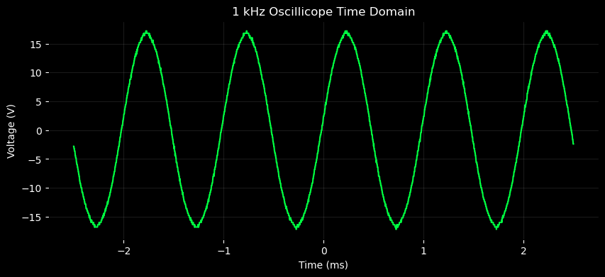
Figure 2: Oscilloscope hardware FFT spectrum of the 1 kHz signal. The dominant peak occurs at 998.76 Hz with a bin resolution of 12.33 Hz. | 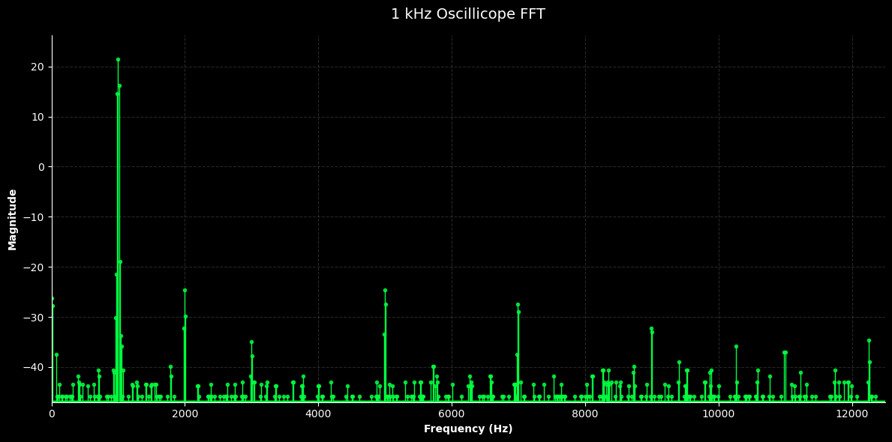
Figure 3: Time-domain waveform of the 5 kHz sine wave. Horizontal scale: $100\frac{μs}{div}$. Vertical scale: $10\frac{V}{div}$. | 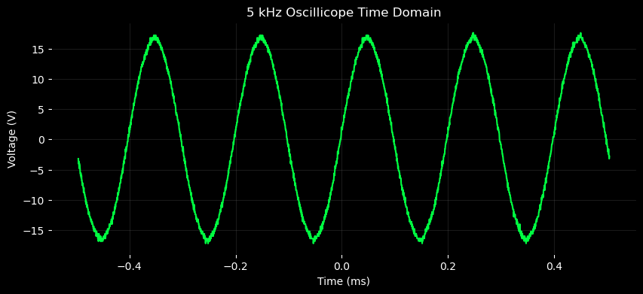
Figure 4: Oscilloscope hardware FFT spectrum of the 5 kHz signal. The dominant peak occurs at 4981.46 Hz with a bin resolution of 49.32 Hz. | 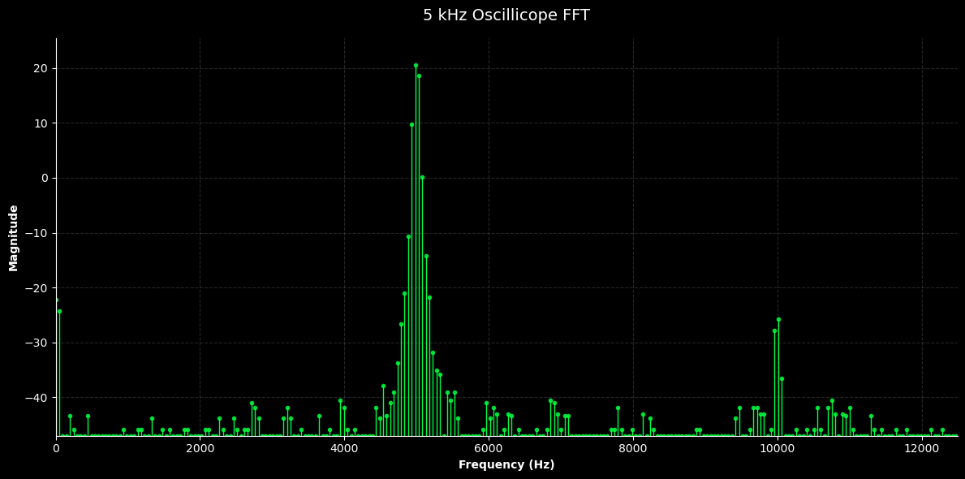
Figure 5: Three-way FFT comparison for the 1 kHz signal: oscilloscope hardware FFT (red), Python software FFT (blue), and simulated ideal FFT (green dashed). Amplitudes are normalized to 0 dB.
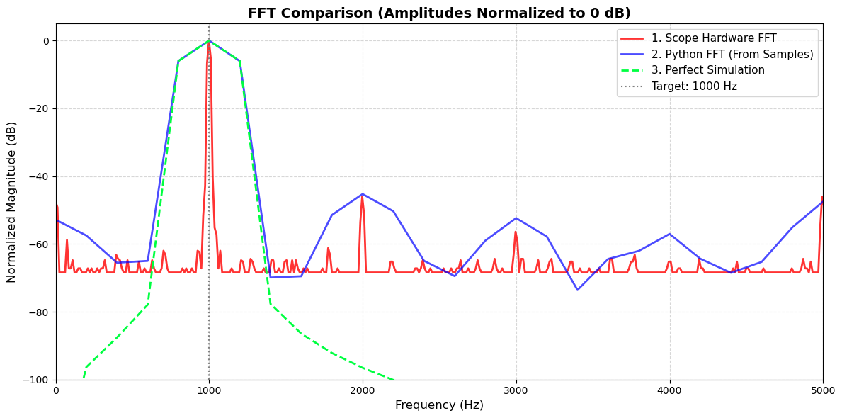
Figure 6: Three-way FFT comparison for the 5 kHz signal, with the same normalization and color scheme as Figure 5.
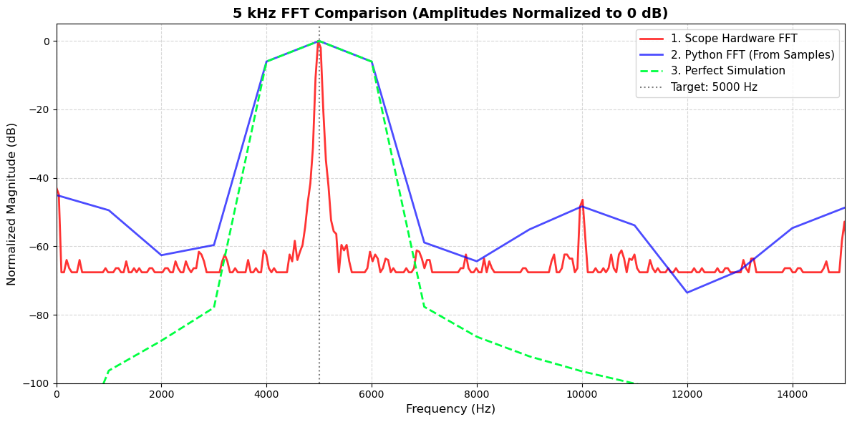

Uncertainty Identification
The dominant source of uncertainty in each frequency measurement is the FFT bin width, which defines the minimum resolvable frequency difference. This is a Type B uncertainty: it arises from the finite resolution of the measurement instrument, not from statistical fluctuations across repeated trials. The bin width for the oscilloscope hardware FFT is determined by its internal processing parameters, while for the Python software FFT it is calculated as $Δf =\frac{f_{s}}{N}$ .
Table 1 summarizes the measured peak frequencies, uncertainties, and calculated quantities for all four measurements.
Table 1: Summary of frequency measurements. The measured peak frequency z, standard uncertainty $s_{z}$ (FFT bin width), and t-value for each measurement technique and target frequency.
Measurement | $μ$ (Hz) | $z$ (Hz) | $s_{z}$ (Hz) | $$t$$ | Result
1 kHz Scope FFT | 1000.00 | 998.76 | 12.33 | 0.101 | Agree
1 kHz Python FFT | 1000.00 | 1000.00 | 200.00 | 0.000 | Agree
5 kHz Scope FFT | 5000.00 | 4981.46 | 49.32 | 0.376 | Agree
5 kHz Python FFT | 5000.00 | 5000.00 | 1000.00 | 0.000 | Agree

Statistical Comparison via t-Test
Following Section 14 of the Measurement and Uncertainty reference, the significance of the discrepancy between the measured peak frequency z and the expected frequency μ is assessed with the t-test:
$$t =\frac{\left|μ - z\right|}{s_{z}}$$
where $s_{z}$ is the standard uncertainty (bin width). According to Table 4 of the reference (Normal/Gaussian PDF significance probabilities), a $t$-value of 1.0 corresponds to a 68% probability of a significant difference. All four measurements yield $t < 1.0$, meaning the expected frequency falls within $±1$ standard deviation of the measured peak in every case.

Sample Calculation: 1 kHz Oscilloscope Hardware FFT
The oscilloscope reports a bin spacing of 12.33 Hz and a peak frequency of 998.76 Hz. The expected frequency from the function generator dial is 1000.00 Hz. The t-value is:
$$t =\frac{\left|1000.00 - 998.76\right|}{12.33}=\frac{1.24}{12.33}= 0.101$$
A t-value of 0.101 falls well below 0.5 in Table 4, corresponding to less than a 38% probability of a significant difference. The measurement and expectation are fully consistent.

Sample Calculation: 5 kHz Oscilloscope Hardware FFT
At 5 kHz, the oscilloscope’s bin width increases to 49.32 Hz due to the wider frequency range. The measured peak is 4981.46 Hz, giving:
$$t =\frac{\left|5000.00 - 4981.46\right|}{49.32}=\frac{18.54}{49.32}= 0.376$$
Although the absolute discrepancy (18.54 Hz) is larger than at 1 kHz (1.24 Hz), the proportionally larger bin width keeps the t-value below 1.0. The difference remains not statistically significant.

Gaussian Uncertainty Distributions
To visualize the statistical meaning of each measurement, Normal (Gaussian) probability density functions were constructed following Equation 8 of the reference:
$$f(x) = \left(\frac{1}{\sqrt{2πσ}}\right)exp\left[-\frac{{\left(x - μ\right)}^{2}}{2σ^{2}}\right]$$
Each Gaussian is centered on the measured peak frequency z (the best estimate of the true frequency) with a standard deviation equal to the bin-width uncertainty $s_{z}$. The measured value $z$ sits at the maximum of the distribution because it is the most probable value given the data. The curve then falls off symmetrically: 68% of the total area lies within $±1s_{z}$ of $z$, meaning there is a 68% probability that the true frequency resides in this interval (the one-sigma confidence interval for a Normal PDF, per the reference).
The expected frequency μ is plotted on each Gaussian to show where the dial setting falls relative to the distribution. When $μ$ lies near the peak (small t), the expected value resides in a high-probability region, confirming agreement. Were $μ$ to lie in the tails ($t > 2$ or 3), it would occupy an extremely low-probability zone, indicating a statistically significant discrepancy.
Figures 7 through 10 present the Gaussian uncertainty distributions for each of the four measurements. In all cases, the expected frequency (red vertical line) falls well within the central high-probability region of the Gaussian, consistent with the t-values reported in Table 1.

Figure 7: Gaussian uncertainty distribution for the 1 kHz oscilloscope hardware FFT measurement. The blue curve is the Normal PDF centered on z = 998.76 Hz with σ = 12.33 Hz. The shaded region indicates the 68% confidence interval. The red line marks the expected frequency μ = 1000 Hz. t = 0.101.
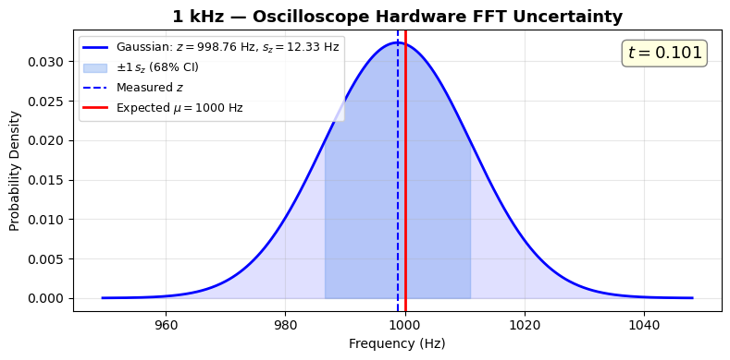
Figure 8: Gaussian uncertainty distribution for the 1 kHz Python software FFT measurement. z = 1000.00 Hz, σ = 200.00 Hz, t = 0.000. The broad distribution reflects the coarse bin resolution; the exact alignment of z with μ is a consequence of the target frequency coinciding with a bin edge.
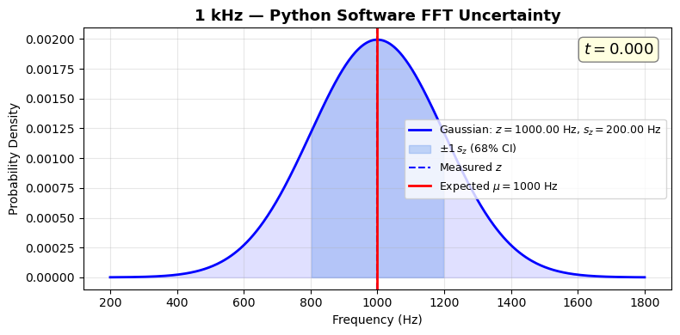

Figure 9: Gaussian uncertainty distribution for the 5 kHz oscilloscope hardware FFT measurement. z = 4981.46 Hz, σ = 49.32 Hz, t = 0.376.
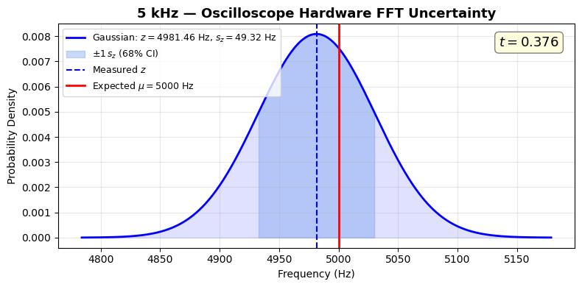
Figure 10: Gaussian uncertainty distribution for the 5 kHz Python software FFT measurement. z = 5000.00 Hz, σ = 1000.00 Hz, t = 0.000.
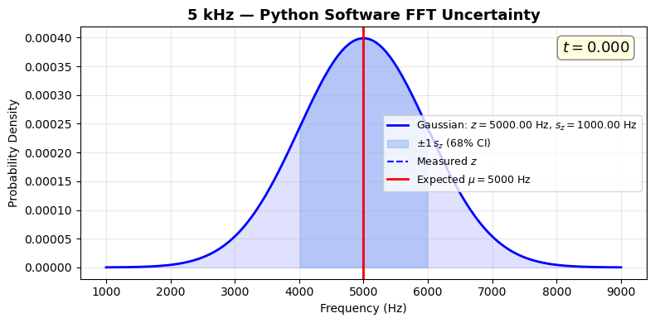

Results
The final results for each measurement, reported with uncertainty, confidence interval, and assumed PDF, are:
- 1 kHz Oscilloscope FFT: $f = \left(998.76 ± 12.33\right)$ Hz (68%, Normal PDF)
- 1 kHz Python FFT: $f = \left(1000.00 ± 200.00\right)$ Hz (68%, Normal PDF)
- 5 kHz Oscilloscope FFT: $f = \left(4981.46 ± 49.32\right)$ Hz (68%, Normal PDF)
- 5 kHz Python FFT: $f = \left(5000.00 ± 1000.00\right)$ Hz (68%, Normal PDF)
All t-values fall below 1.0 (Table 1). Referring to Table 4 of the Measurement and Uncertainty reference, a t-value of 0.376 (the largest observed) corresponds to less than a 38% probability of a significant difference. At the standard threshold for significance ($t > 2$, corresponding to 95% probability), none of the measurements approach a statistically significant discrepancy with the function generator’s dial settings.
The oscilloscope hardware FFT consistently provides higher-resolution measurements (smaller bin widths) than the Python software FFT, because the oscilloscope’s internal FFT uses finer frequency sampling than the bin spacing dictated by the exported record length.

Discussion
The BK Precision 4011A function generator produces frequencies consistent with its dial settings at both 1 kHz and 5 kHz, as confirmed by two independent FFT measurement techniques. The Gaussian uncertainty distributions (Figures 7–10) provide a clear visual interpretation of this result: in every case, the expected frequency lies near the center of the measurement’s probability distribution, well within the 68% confidence interval.
The Python software FFT’s t-values of exactly zero should not be interpreted as perfect accuracy. As discussed in the analysis, the FFT can only report frequencies at discrete bin locations. When the target frequency coincidentally aligns with a bin edge, the measured peak matches exactly, but the underlying uncertainty (200 Hz for 1 kHz, 1000 Hz for 5 kHz) remains large. The Gaussian distributions for these measurements (Figures 8 and 10) make this limitation visually apparent through their broad widths.
The oscilloscope hardware FFT, by contrast, provides substantially finer resolution (12.33 Hz and 49.32 Hz), resulting in narrower Gaussian distributions and more informative measurements. The small but nonzero offsets visible in Figures 7 and 9 (1.24 Hz and 18.54 Hz, respectively) likely reflect a combination of the function generator’s analog tuning precision and the discrete nature of the FFT bins, rather than a systematic calibration error.
A limitation of this experiment is that only single acquisitions were taken at each frequency. Multiple independent acquisitions would enable a Type A (statistical) uncertainty analysis in addition to the Type B (bin-width) analysis performed here, potentially yielding a more complete characterization of the measurement’s total uncertainty. Future work could extend this calibration across additional frequencies spanning several orders of magnitude, as suggested in the lab procedure.

References
[1] Measurement and Uncertainty, PHYS 263 course notes.
[2] BK Precision 4011A Function Generator data sheet.
[3] Tektronix TBS1000B Series Digital Oscilloscope User’s Manual.

